Adaptive Online Platform for Enhanced Teaching and Learning

Amod Katiyar
Computer Science
KIET Group of Institution
Ghaziabad, Uttar Pradesh, India
amod.2024cs1058@kiet.edu

Himanshu Kumar
Computer Science
KIET Group of Institution
Ghaziabad, Uttar Pradesh, India
himanshukumarrai786@gmail.com
Aniket Bhardwaj
Computer Science
KIET Group of Institution
Ghaziabad, Uttar Pradesh, India
aniket.2024cs1199@kiet.edu

Abstract—
In this vastly expanding world with thousands of opportunities, it can be extremely difficult for students to decide and pursue what they truly enjoy and are passionate about. With the rise of new technologies, the most pressing question for students today is what to learn and how to learn.
Students find it difficult to learn even though there are numerous options, and everything is so diverse. Nothing can ever be found on a single platform. We intend to solve this issue.
We will provide a platform that will give students an idea about the languages that are currently the most sought after in the industry, as well as a road map and resources from various platforms that will allow students to hone their grasp on the fundamental concepts and the entire language.
Introduction
Technological advancements have dramatically increased access to learning materials and are rapidly changing the educational landscape. With the advancement of internet and mobile phone technology, more education and learning can take place online—on laptop computers, tablets, and mobile phones. Everyone with internet access can benefit from online courses. Learners interested in a specific topic are brought together to learn collaboratively via discussion forums, tweets, and other internet resources.
The platform that we intend to build will provide a platform for comparing different existing languages that are currently the most in demand in the industry. The comparison will help students decide which language to pursue for future endeavours. The students will also learn about the various opportunities that will be available to them after learning a specific language.
Furthermore, the students will be able to share their own hands-on experience and will be able to guide and assist others in their learning journey. Various resources from renowned platforms will be provided, as well as a road map for getting better and better at that specific language.

PROBLEM STATEMENT

Despite the fact that there are many options and that everything is so diverse, students find it difficult to learn. Nothing can ever be found on a single platform. We intend to resolve this issue.

The numerous possibilities that a student faces when deciding on a Specific domain to work in, the numerous questions that arise in his mind as to whether this is suitable for me or not, whether it will help me land a job in an MNC or not

Even after deciding on a domain, the next question is how to get there, how to get started, and how to properly learn each and every concept.

How to practice and revise concepts to achieve the best results. Instead of spending hours researching which courses to take and which channels to follow on the internet, our platform has already done all of the legwork for you, saving you a lot of time. Furthermore, all of that content will be available in a single location.

OBJECTIVE

Our goal is to address the issues that students face on a daily basis, which may not seem significant at first but can be extremely harmful in the long run. Choosing a domain that does not excite you or is not of your interest and devoting time to it will result in time wasted.
It is pointless to learn essentially extinct technologies that have been replaced by newer and more advanced technologies. Knowing the current industry trend and selecting a domain based on it will prove fruitful to you.
Following a dedicated roadmap to learn the respective languages will assist students in learning the fundamental concepts and thereby strengthening their foundation. Learning the concepts in the prescribed order ensures that no important topics are overlooked, and that the student has a thorough understanding of each and every topic.

Scope

In the future, we will provide a much simpler user interface as well as various other resources to improve the quality of content offered.

We will also be providing certification for the specific languages learned as well as practice sets for students to test their skills in real time.

Offering a premium membership that includes dedicated videos on important topics as well as live sessions with pre-experienced people who are already working in their respective fields.

Students who have completed all the test series on the given topics will receive paid certified certification, and dedicated questions focusing on placements will also be provided.

METHODOLOGY

We are starting with the most popular courses or languages. Then, we will use NLP and API to extract the best links from the web for students to learn from.

All of this will be done to assist the student in choosing his path and provide him with the resources he needs to succeed.

We will deploy a model of recommended systems that will analyze historical data and trends to determine the popularity and usage of languages such as Java, C, and Python and then recommend it to students.

We will also show this in real-time graphs. Finally, we will use NLP to extract words like Python data science best top to analyze and recommend courses. We will also use API for this.
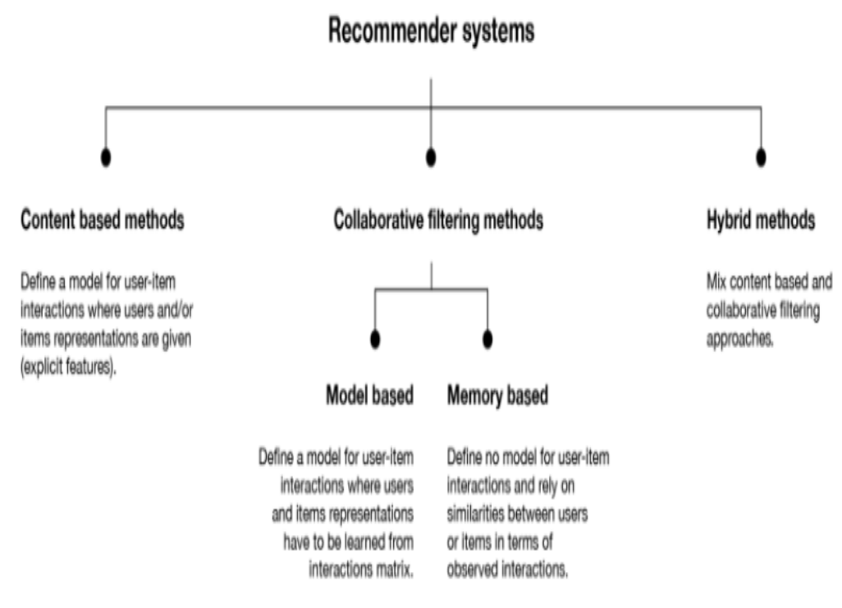
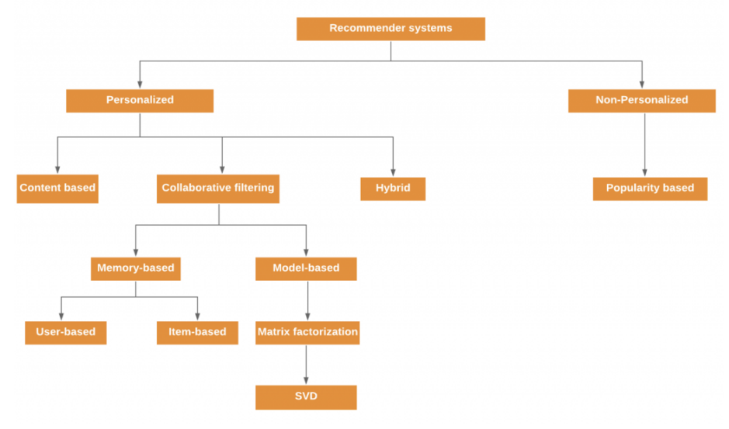

TECHNOLOGY USED

The platform's development has been divided into two parts: frontend and backend. The front end will be built with HTML and CSS, where HTML will provide the basic framework for the website and CSS will be used for styling.
The goal is to create an easy-to-use website that is user-friendly and easy to navigate ^{[1]}.

The backend will be built with React, Express, and Node JS, as well as JavaScript. React and JavaScript will provide the functionality to the website, as well as the necessary post and get requests ^{[1]}. MongoDB will be used to create a database that will store the students' information as well as their current progress ^{[2]}.
React will also be used to improve the overall interface of the website, which when combined with the backend will result in the perfect website ^{[3]}.

Machine learning techniques are used in industry to implement real-time language usage. the rate at which the particular language is growing and the language's future trends.
The domains that are currently required in the industry, as well as the average salary trends for jobs in the respective domain.

Implementation

Predicting Future Languages
Data Collection:
Your code starts by reading data from JSON files representing GitHub events related to issues, pull requests, and stars.
These JSON files are combined into a single dataset to facilitate data processing ^{[6]}.

Data Preprocessing:
The collected data is organized by grouping it based on years, language names, and counts.
This preprocessing step structures the data for time series analysis.

Time Series Analysis:
Auto-Regressive Integrated Moving Average (ARIMA) models are utilized for time series analysis.
The ARIMA models are applied to predict the future trends in language popularity ^{[9]}.

Model Parameter Tuning:
For each language, the ARIMA model parameters, including order and seasonal order, are fine-tuned to optimize predictive accuracy.
The code uses Mean Absolute Error (MAE) as the evaluation metric to determine the best model ^{[9]}.

Best Model Selection:
The ARIMA models are evaluated for each language, and the best-performing model is chosen based on the lowest Mean Absolute Percentage Error (MAPE) ^{[10]}.

Predictions and Visualization:
Once the best models are selected, they are used to forecast language counts for the years 2023, 2024, and 2025.
Visualizations are created to provide clear insights into expected language popularity trends.

Results:
The code aims to improve the Akaike Information Criterion (AIC) and Bayesian Information Criterion (BIC) values by refining the model parameters.
Enhanced visualizations are generated to represent the forecasted data effectively.
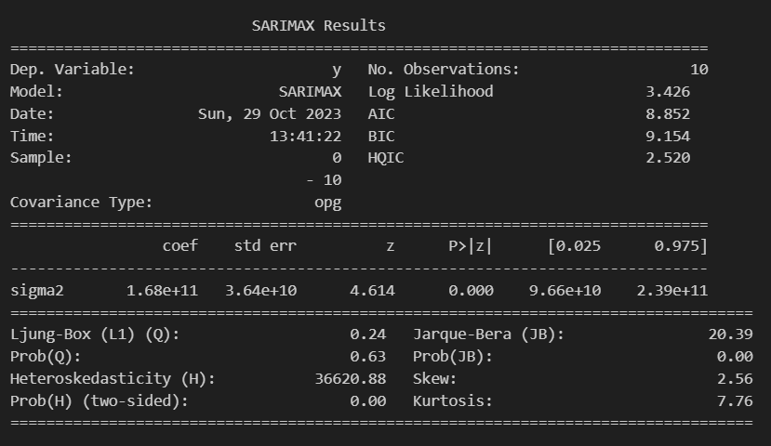

Overall Interpretation:
When analyzing ACF and PACF plots, look for significant peaks outside the confidence interval.
Peaks in ACF indicate potential seasonal patterns or moving average (MA) components ^{[8]}.

Peaks in PACF suggest potential AR components.
The combined information from ACF and PACF can guide the selection of parameters for time series models like ARIMA or SARIMA ^{[8]}.

In summary, ACF and PACF plots are valuable for identifying autocorrelation structures in time series data and serve as a guide for selecting appropriate models. Peaks in these plots help you determine the orders of AR and MA components and understand the seasonality of your time series ^{[8]}.

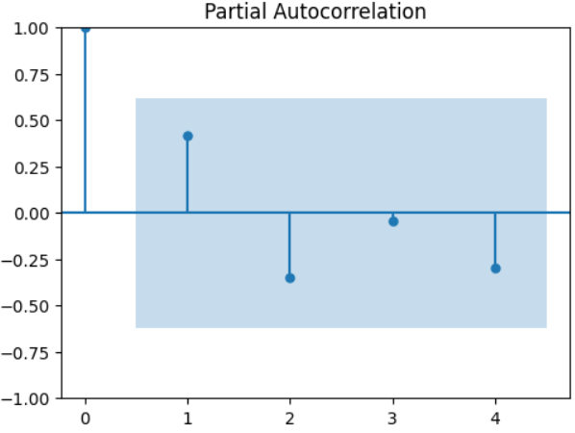

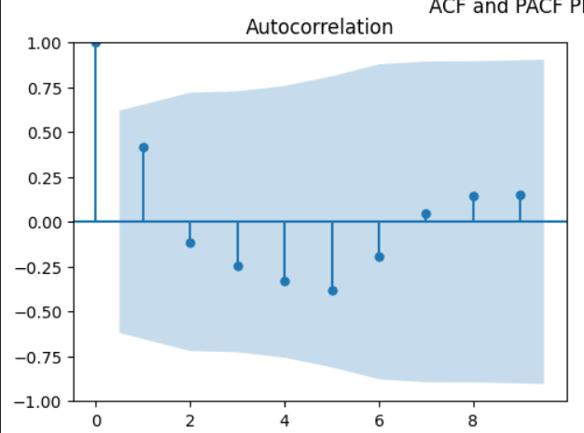

Acknowledgment
It gives us a great sense of pleasure to present the synopsis of the B. Tech Mini Project undertaken during B.Tech. Third Year. We owe a special debt of gratitude to Dr. Gaurav Dubey (Professor), Department of Computer Science, KIET Group of Institutions, DelhiNCR, Ghaziabad, for his/her constant support and guidance throughout the course of our work. His sincerity, thoroughness and perseverance have been a constant source of inspiration for us. It is only his cognizant efforts that our endeavours have seen the light of the day.
We also take the opportunity to acknowledge the contribution of Dr. Ajay Kumar Shrivastava, Head of the Department of Computer Science, KIET Group of Institutions, Delhi- NCR, Ghaziabad, for his full support and assistance during the development of the project. We also do not like to miss the opportunity to acknowledge the contribution of all the faculty members of the department for their kind assistance and cooperation during the development of our project.
Last but not the least, we acknowledge our friends for their contribution to the completion of the project.

References
- A review and analysis of technologies for developing web applications, BY-SOLOMON ANTONY

- Web Application Development -a study on UML Web Application Extension, Andreas Oskarsson, Martin Kling, Tobias Norberg

- Research on HTML5 in Web Development, Ch Rajesh, K S V Krishna Srikanth

- Review of WordPress website vs coding website By-Swapnil S More

- Website Development Technologies: A Review By - Pratiksha D Dutonde , Shivani S Mamidwar , Monali Sunil Korvate

- Big Data-Based Improved Data Acquisition and Storage System for Designing Industrial Data Platform By DAOQU GENG , CHENGYUN ZHANG , CHENGJING XIA , XUE XIA , QILIN LIU , AND XINSHUAI FU

- Exploratory Analysis for Big Social Data Using Deep Network By CHAO WU, GUOLONG WANG , JIANGCHENG ZHU , PIYAWAT LERTVITTAYAKUMJORN , SIMON HU , (Member, IEEE), CHILIE TAN , HONG MI, YADAN XU AND JUN XIAO

- Mining Conditional Functional Dependency Rules on Big Data By Mingda Li, Hongzhi Wang, and Jianzhong Li

- Big Data Analytics and Mining for Effective Visualization and Trends Forecasting of Crime Data By MINGCHEN FENG, JIANGBIN ZHENG, JINCHANG REN , (Senior Member, IEEE), AMIR HUSSAIN , (Senior Member, IEEE), XIUXIU LI , YUE XI , AND QIAOYUAN LIU

- Social Set Analysis: A Set Theoretical Approach to Big Data Analytics By RAVI VATRAPU1,2, RAGHAVA RAO MUKKAMALA1 , ABID HUSSAIN1 , AND BENJAMIN FLESCH

